User Interface : The point from where user interacts with application

Character Based / Graphical Based

Console Applications > Gives you CUI

Graphical Interface

Windows Applications/ Web Applications

Console / Windows Applications are stand alone , eg. MS Word.

Web Applications can be accessed from anywhere.. How do we access them , using Browser

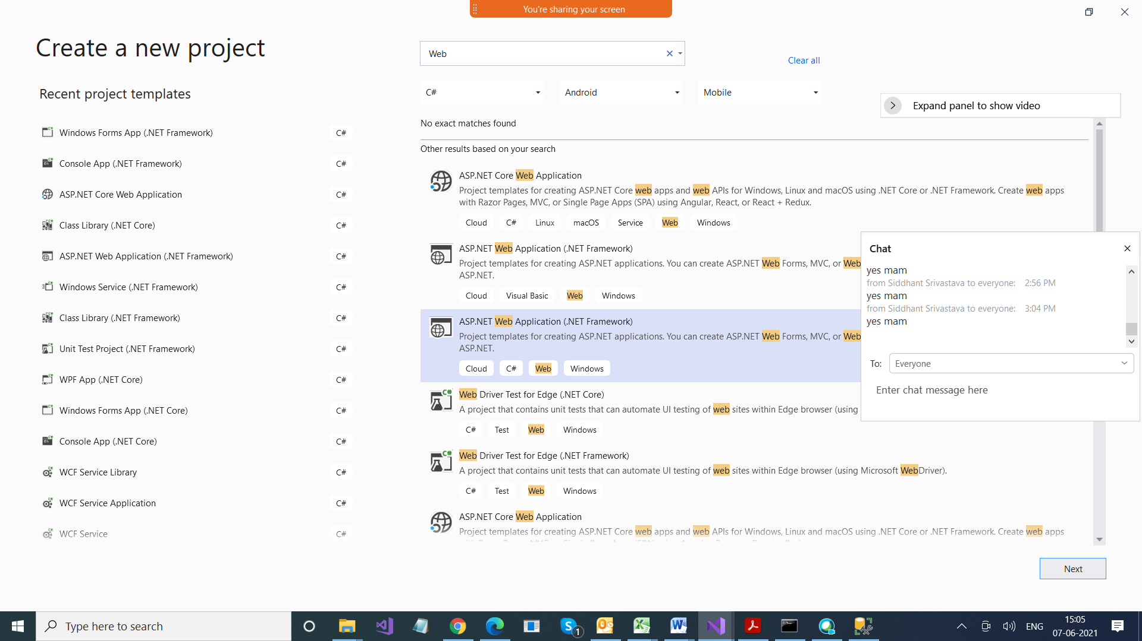

Blank Project

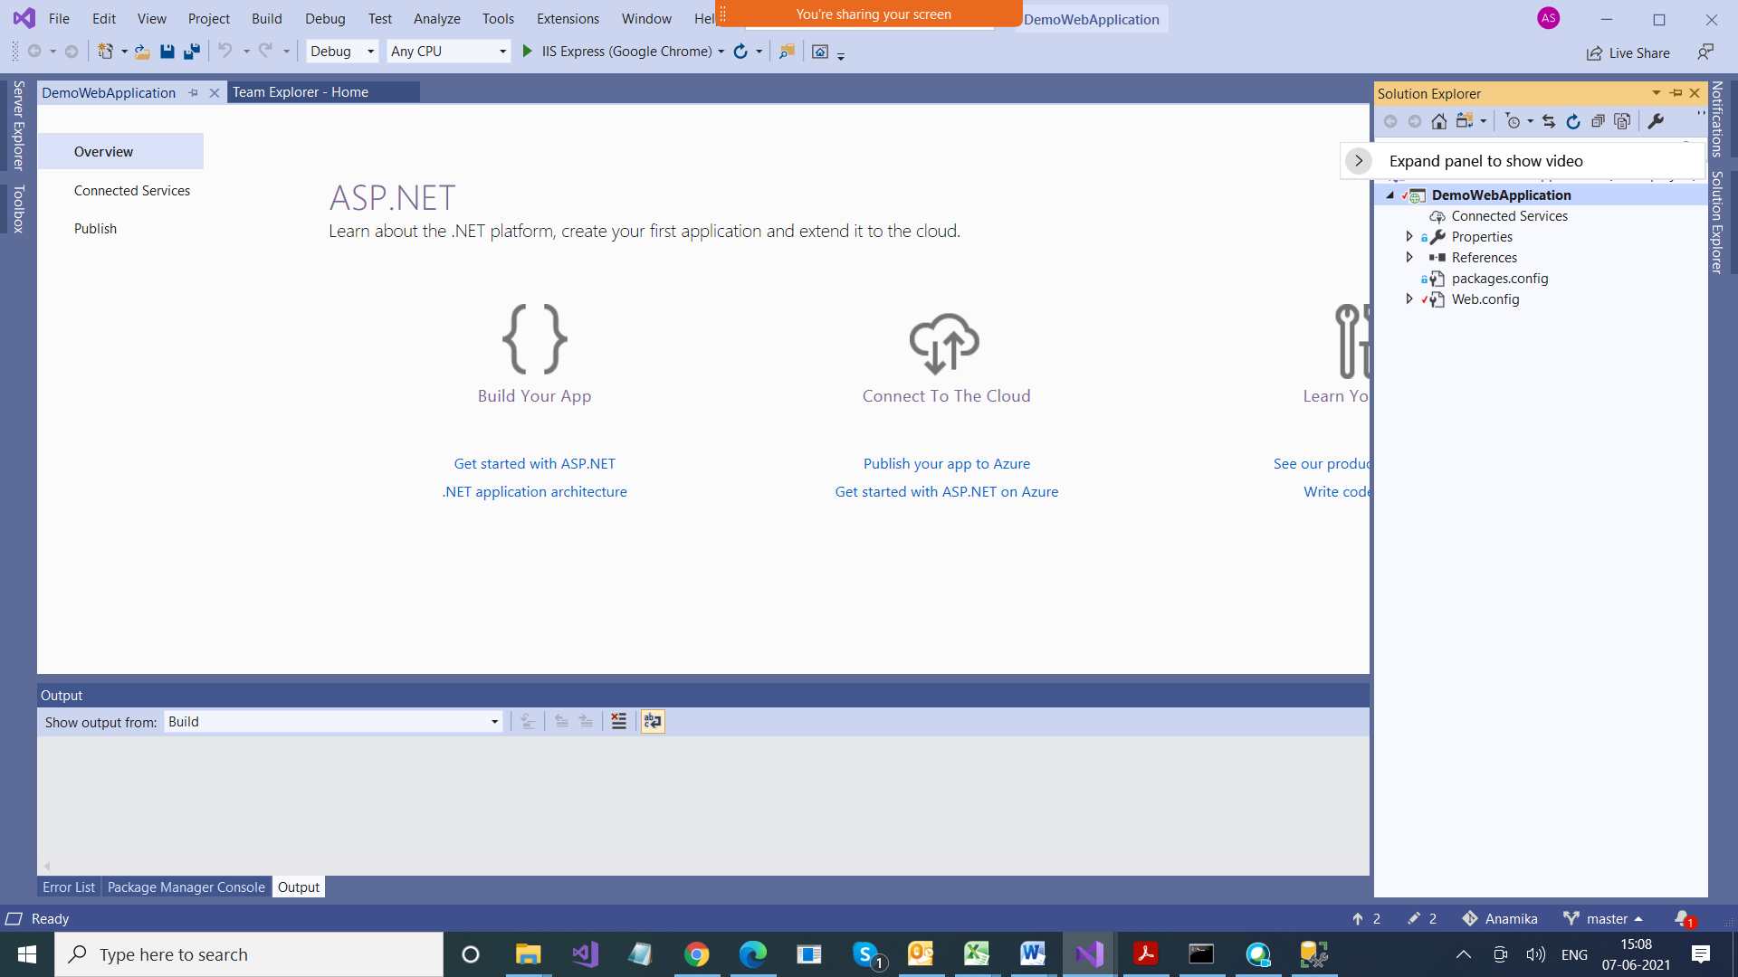

Web Forms

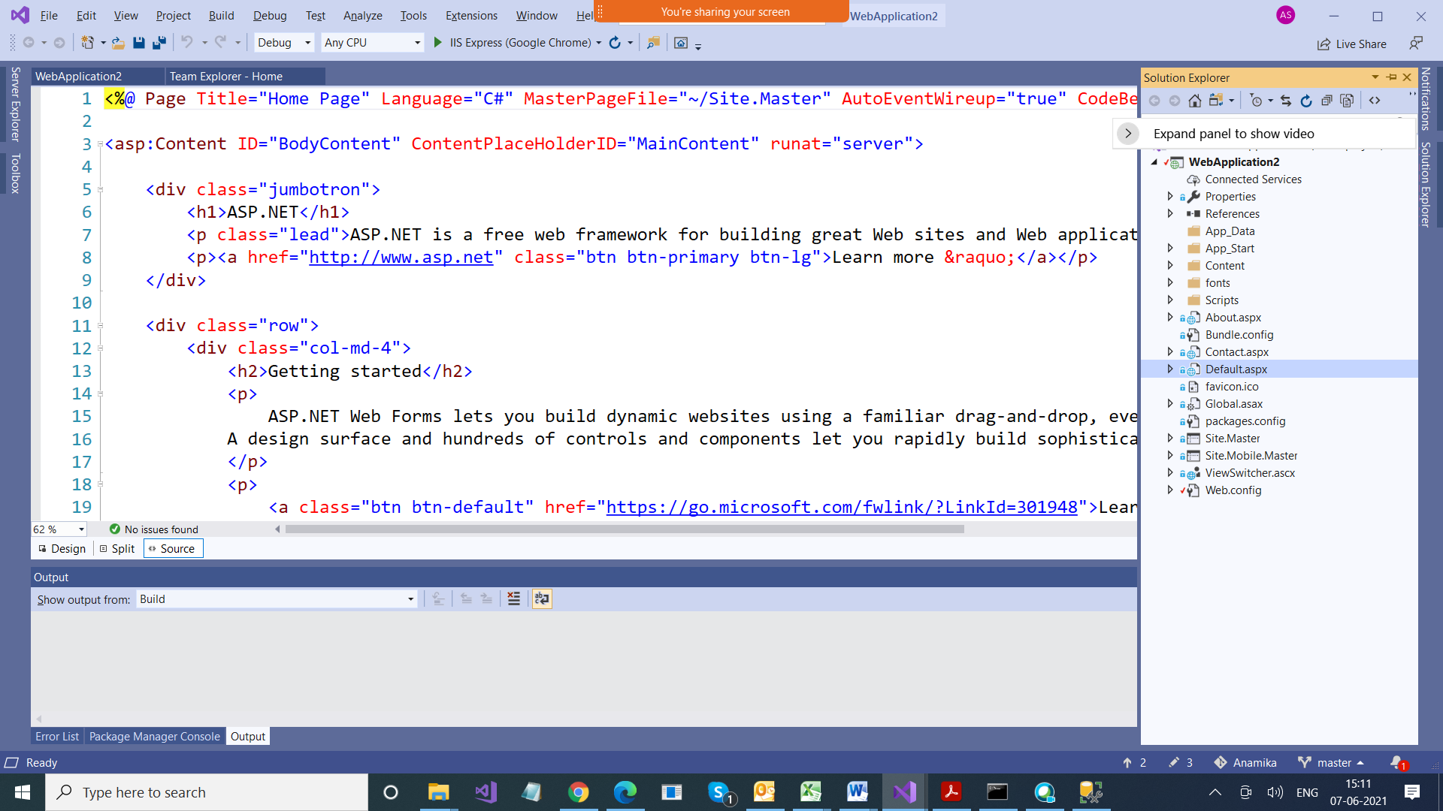

MVC

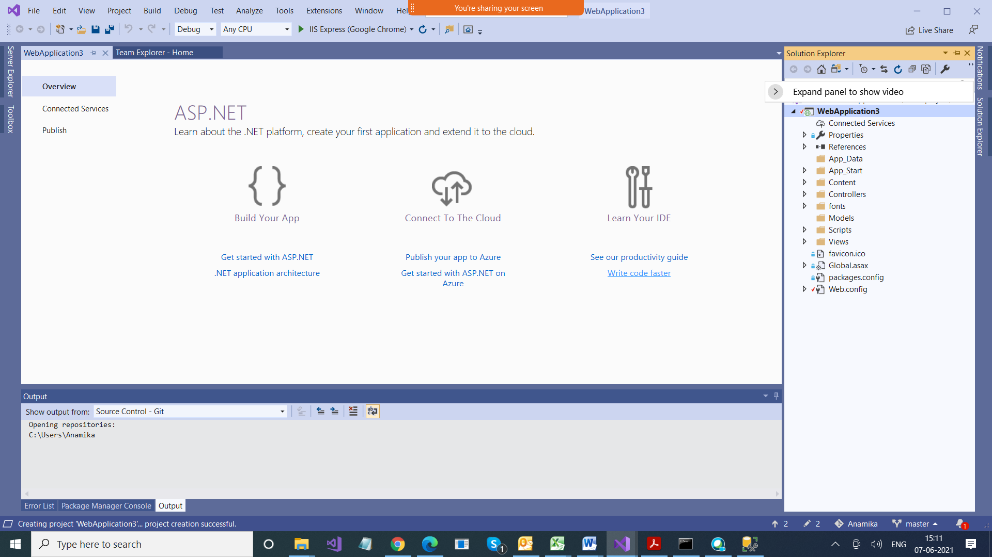

MVC > Model View Controller

Model > Represents your Data/Domain

View > html pages

Controllers > Request Handlers

<https://localhost:44307/>

Why https / http coming ?

http is protocol ? Why > Because we are talking client server, which cud be different machines too

that when we communicate between two machines,

they cud be of different confi. So to make them compatible we use some rules for communications, and those are known as protocol

Because we are running web application

Web Applications always follows client server arch

Server is what > is a machine where is application is hosted

(IISExpress is local server)

Client > browser

Localhost > server , right now our server is also on same machine (IISExpress)

